Project Design Phase-II

Data Flow Diagram & User Stories

|  |  |
| --- | --- |
| Date | 15 October 2022 |
| Team ID | PNT2022TMID51465 |
| Project Name | AI-powered Nutrition Analyzer for Fitness Enthusiasts |
| Maximum Marks |  |

**Data Flow Diagrams:**

Simplified Diagram

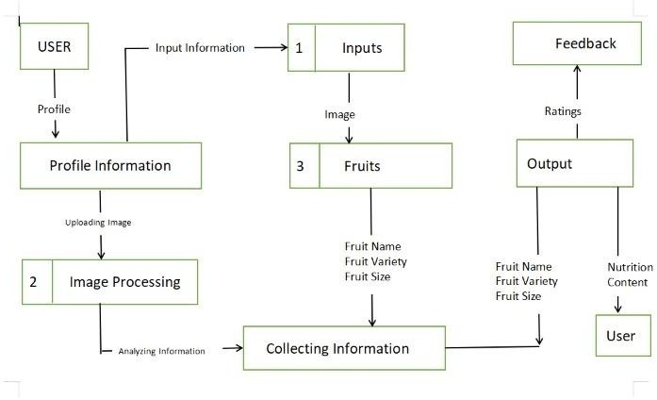

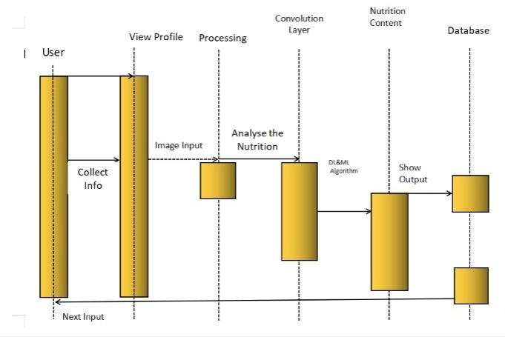

**User Stories**

|  |  |  |  |  |  |  |
| --- | --- | --- | --- | --- | --- | --- |
| **User Type** | **Functional**  **Requirement (Epic)** | **User Story Number** | **User Story / Task** | **Acceptance criteria** | **Priority** | **Release** |
| Customer (Mobile user) | Registration | USN-1 | As a user, I can do registration by my mobile and get confirmation email | I can access my account / dashboard | High | Sprint-1 |
| Customer (Web user) | Registration | USN-2 | As a user, I can register for the application  by entering my email, password, and confirming my password | I can access my account / dashboard | High | Sprint-1 |
|  |  | USN-3 | As a user, I will receive confirmation email once I have registered for the application | I can receive confirmation email & click confirm | High | Sprint-1 |
|  |  | USN-4 | As a user, I can register for the application through other social media | I can register & access the dashboard with Login | Low | Sprint-2 |
|  | Login | USN-5 | As a user, I can log into the application by entering email & password | I can successfully logged in to the home page | High | Sprint-1 |
|  | Dashboard | USN-6 | As a user, I can select the list of options provided in the dashboard | I can access the options according to my need | Medium | Sprint-1 |
|  | Search | USN-7 | As a user, I can search for different variety of fruits | I can get the nutrition content of different fruits | High | Sprint-2 |
|  | View | USN-8 | As a user, I can view the list of fruits | I will get the information such as calories,vitamins etc | High | Sprint-2 |
|  | Notifications | USN-9 | As a user, I will receive notification about variety and textures of different fruits | I will get the frequent updates of different fruits | Low | Sprint-2 |
| Customer Care Executive | Mediator | USN-10 | As a customer care executive ,they could take care of customer feedbacks and solve  user requirements | Users can get help and support from customer care  executives | Medium | Sprint-2 |
| Administrator | Database | USN-11 | As a admin,I will store the user database confidentially | I can store and access data if it is needed in future | High | Sprint-1 |
|  | Data Information | USN-12 | As a admin, I will include the dataset for performing various processes | I can store dataset and analyse it | High | Sprint-2 |
|  | Processing | USN-13 | As a admin, I will use various convolution layers for image analysis | I can process using various convolution layers | High | Sprint-2 |
|  | Nutrition Analyzer | USN-14 | As a admin, I will predict the fruit that has send as input | I can get the nutrition content  of particular food after processing and display it | High | Sprint-2 |